Plot of detection*count. Legend: A = 1 obs, B = 2 obs, etc.
detection |
39600 + Z
| C
|
| DH
36300 +
|
| D
|
33000 +
|
|
| B
29700 + PE D B
| C D
| D
|
26400 +
| I
| G
| C
23100 + Z
| D
|
| DHD CC
19800 + DGZ C E
| AID I C
| FG A
| DZG A A A
16500 + AFAD
| AH D
| DA D A D D B
| B E D A
13200 + B HD D D
| ABB B A
| BB B A A A
| CB D DD E D D A
9900 + AZE C S D A A
| DDB O DH A D B
| EF M Z A D
| EA AG Z AC D A D
6600 + CA B E
| QQB A ACX D D A A
| D DHDLD D S
| ANT AH D P F B
3300 + AC D B
| RFD D H E
| AIZ D AD AD F
| PRZ DD A A D H Z DD X L
0 + ZZD DDFDEGEBIEAEBBBJTVVLHBBHIL HLHH D ZDD DZD DH D H Z
---+------------+------------+------------+------------+------------+------------+------------+------------+--
0 5000 10000 15000 20000 25000 30000 35000 40000
count
NOTE: 3906 obs hidden.

Number of Observations Read | 5410
Number of Observations Used | 5410

Analysis of Variance
Source | DF | Sum of  Squares | Mean  Square | F Value | Pr > F
Model | 1 | 1.082281E11 | 1.082281E11 | 2315.91 | <.0001
Error | 5408 | 2.527291E11 | 46732443
Corrected Total | 5409 | 3.609572E11

Root MSE | 6836.11313 | R-Square | 0.2998
Dependent Mean | 3973.10702 | Adj R-Sq | 0.2997
Coeff Var | 172.05963

Parameter Estimates
Variable | DF | Parameter  Estimate | Standard  Error | t Value | Pr > |t|
Intercept | 1 | 698.39322 | 115.18953 | 6.06 | <.0001
count | 1 | 0.36022 | 0.00749 | 48.12 | <.0001

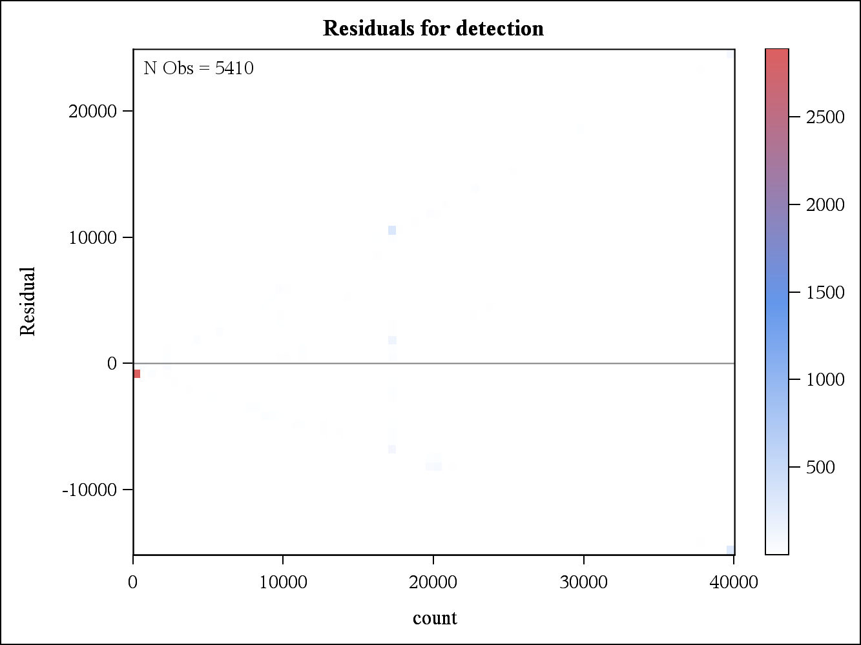

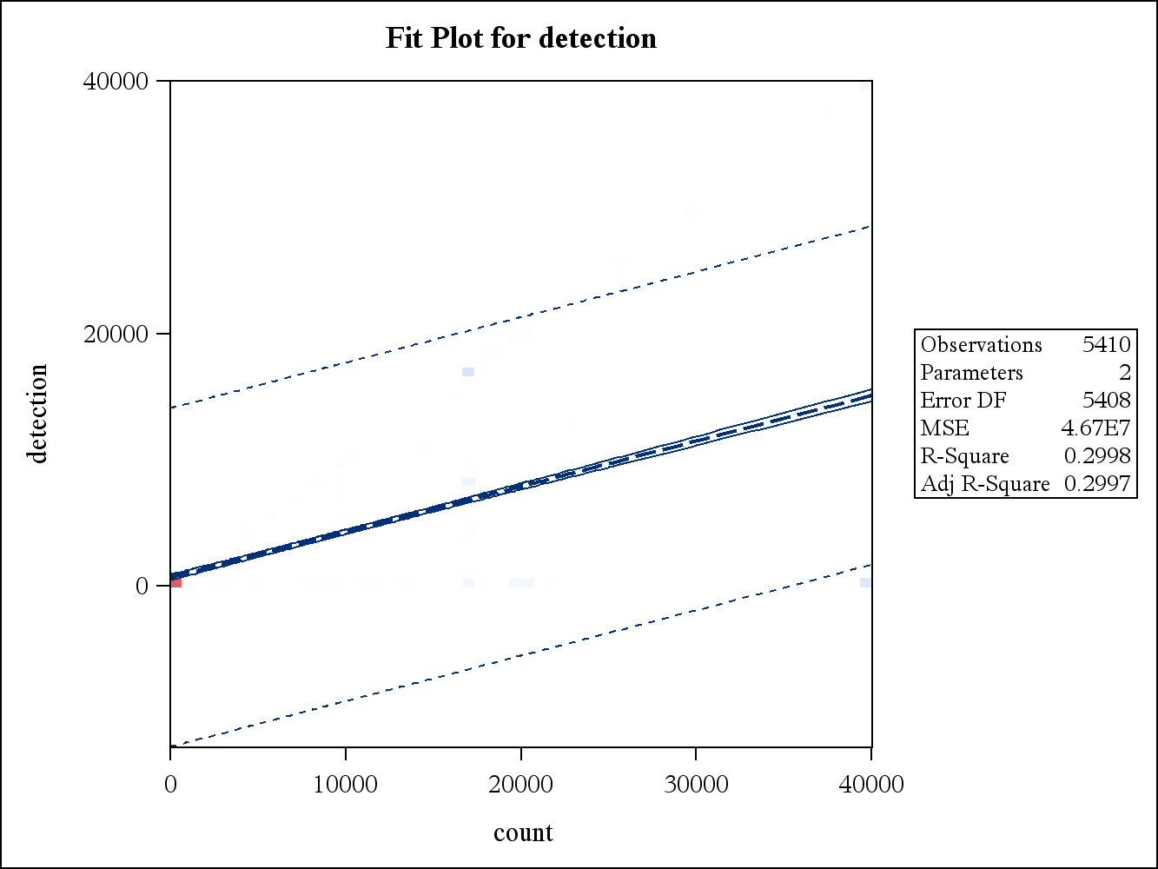
2 Variables: | count detection

Simple Statistics
Variable | N | Mean | Std Dev | Sum | Minimum | Maximum
count | 5410 | 9091 | 12418 | 49181692 | 0 | 40000
detection | 5410 | 3973 | 8169 | 21494509 | 0 | 40000

Pearson Correlation Coefficients, N = 5410
Prob > |r| under H0: Rho=0
 | count | detection
count | 1.00000 | 0.54757  <.0001
detection | 0.54757  <.0001 | 1.00000

